**USABILITY EVALUATION REPORT FOR COMIC RELIEF**

**EVALUATION DONE BY:**

ARINDRA KUMAR DAS ([arindra.das.14@ucl.ac.uk](mailto:arindra.das.14@ucl.ac.uk))

CHRISTIE LAU ([christie@clsnaps.cc](mailto:christie@clsnaps.cc))

LESLEY CARY ([lesley.cary@carydigital.com](mailto:lesley.cary@carydigital.com))

26.11.2014

Version 1.0

**TABLE OF CONTENTS:**

1. **Introduction**
2. **Study methodology**

**2.1 Methodology Limitations**

1. **Positive Findings**

**3.1 Landing page**

**3.2 Donation page**

1. **Key Issues**

**4.1 Landing page**

**4.2 Donation page**

1. **Summary of Findings**
2. **Recommendations**

**6.1 General**

**6.2 Landing page**

**6.3 Donation page**

**Appendix**

**1. INTRODUCTION**

Wow-Elite were commissioned by Comic Relief to conduct usability testing on the Red Nose Day pages (Landing and Donation pages) and to test them on devices in terms of functionality.

**2. STUDY METHODOLOGY**

20-minute one-to-one usability testing sessions were conducted using self-owned mobile devices and laptops. Each participant started with the Landing page and then viewed the Donation page.

Participants were led through the exploration of the two pages by 12 questions. The evaluation was done through think-aloud technique, with pre- and post-questionnaires accompanied by a semi-structured interview.

12 users were involved in the testing, with four participants from each client-defined user group: “Hollyoakers”; “Coronation Streeters”; “My Family”.

Invisionapp mock-ups: Navigation link: <http://invis.io/5X1M71X2J> and Donate page link: <http://invis.io/NG1OPIDJR>

**2.1 Methodology limitations**

The Invisionapp was not ideal for user testing because it gave hints as to which areas are clickable by the green highlights (the highlight shows when you tap on a empty area on the page).

The Invisionapp was not responsive, therefore it was a key issue in user evaluation for small screen devices.

**3. Positive Findings**

**3.1 Landing page**

**GET LATEST:**

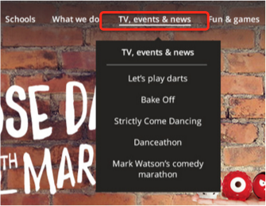

Majority of the users found out the latest on what is going on Red Nose Day from TV, events & News located on the top pull-down menu.

**FREE FUNDRAISING KITS:**

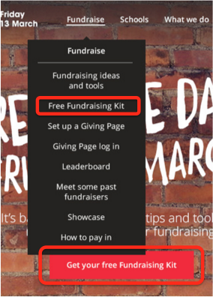

Majority of users easily found the ‘Get your free Fundraising Kit’ from either the red button on the page or drop-down Fundraise menu.

**3.2 Donation page**

Users were aware of this being a donation page due to various reasons such as: standard layout. Although a user (Coronation Streeter) did not know what to expect because she hardly donates online, by seeing all the Currency (pounds, dollars, euro etc.) signs in the page she figured this is a page asking for money.

Users who donated often were familiar with Gift Aid. Most found that the images were engaging and enticing them to donate.

Laptop and Desktop users could easily see the single scrollable page and thought it was quite effective as they knew what all the information they need already. Continuous page design allows user to finish transaction on one single page, without clicking on several confirm buttons.

**IMAGES:**

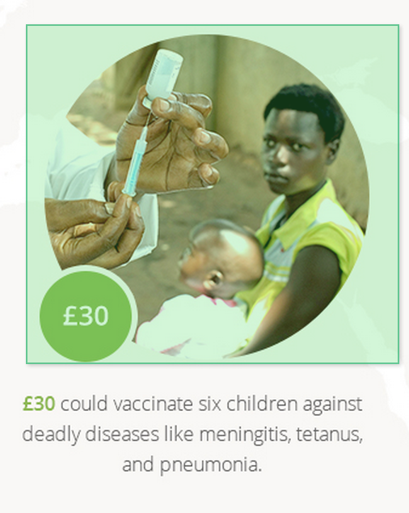

The images gave a bold example of what the donation could impact on and hence a stronger incentive for users to donate. Only two users (a Hollyoaker and a Coronation Streeter) spent time reading the text below the money buys to find out more about the beneficiaries.

**GIFT AID:**

People who had donated earlier were familiar with Gift Aid and that they could claim the tax back on the amount donated. So they ticked the box directly recognizing the Gift Aid logo.

**4. Key Issues**

**4.1. Landing page**

**LOGIN USER ICON:**



Most users were able to locate the user icon in the top right. However, due to the small size and the thin outline of the icon, users at the upper end of the target demographics had difficulty looking for it, especially on a tablet or mobile phone. Two in the the “My Family” category could not find the login at all and it took one user up to 30 seconds to find it.

In Nexus 7, Nexus 5, iPhone6, iPhone5C and Samsung mobile the login in the top right was difficult to find initially and it took sometime due to responsiveness issue.

**LOGIN UNDER FUNDRAISE: (MAIN ISSUE: VISIBILITY, CREEPING FEATURISM, LABELLING)**

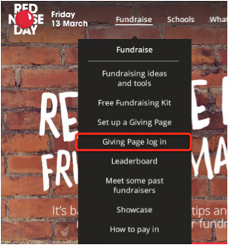

This option was quite critical to find as no one expected it to be underneath the Fundraise.

**GET LATEST: (MAIN ISSUE: FAMILIARITY)**



Except a single user who found the “Get the latest” in top right envelope accidentally while going through the user login, all the rest were unable to locate it in the top right corner. Two users mistook the top right envelope label as a potential spot for login.

**FREE FUNDRAISING KIT: (MAIN ISSUE: FAMILIARITY)**



Although everyone could easily locate the “Fundraising kit”, many were not aware of what is the fundraising kit, as they have never donated before in a similar campaign.

On tablets, the copy on the button “Get your free fundraising kit” appeared too small to be recognised.

It was also observed that, two users clicked on “Get your fundraising kit” button in an attempt to find out latest news, including one user who’s not familiar with Red Nose Day and another knowing very well what’s Red Nose Day.

**4.2 Donation page (MAIN ISSUE: NAVIGATION IN MOBILE PHONES)**

The length of donation page was not suitable for mobile users. Some users felt that the money buys with green buttons and images was the totality of the page and there were nothing else below them, *“I was not aware that you had to go further down”*. Accessing the bottom part of the page required a lot of scrolling from the users viewing on mobile phones (A user explicitly stated that she would prefer a multi-page layout, which groups each of the vertical scroll section as one page).

**MONEY BUYS:   
(MAIN ISSUE: LABELLING, VISIBILITY, FEEDBACK, FREEDOM OF CHOICE/CONTROL, ENTRY BARRIER, AFFORDANCE)**

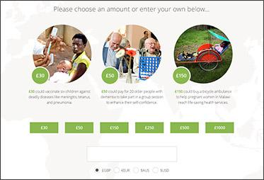

Users did not realize the money buys were clickable (cognitive affordance). As mentioned in methodology limitations, invisionapp prompted users on the clickable areas and one user then realised the money buys were clickable. Also, there was no direct feedback when a button was clicked.

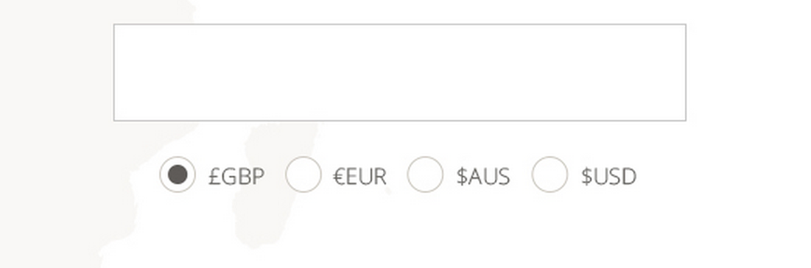

Confused with what the amount input field does. Users thought that it was not possible to enter an amount lower than £30 in the box below. “How would you donate less than that? Some user (Hollyoakers) not able to afford £30, they might want to give £5 or £10”.

Furthermore, user opinions were mixed on whether the money buys were clickable and what it meant if they clicked on the round images or square images.

A user (Coronation streeter) found it difficult to do multiple donation as it was not an option and she was willing to donate £30 and £50 (she said she is touched by both the cause of children and elderly people as shown in the image).

“My Family” users felt that this was off putting, as *“It is easier to click a box for £30 than it is to key in yourself £10 or £20”*, and felt that the vast majority of people would be donating smaller sums than £30.

Other similar quotes from users:

“*You are more likely to get £10 out of someone than £25, £50 or £100” ,*

*“ I think personally you are better giving someone a box (entering an amount in a box), rather than starting it off at £30.”*

For users (Hollyoakers and Conoration Streeters) who had figured out that the box below allowed them to input alternative donation amounts, they found it discouraging or embarrassing when the minimum amount suggested (in both money buys and the smaller green rectangular button) was £30 but what they could afford was only £5 or £10.

**IMAGES: (MAIN ISSUES: FAMILIARITY)**

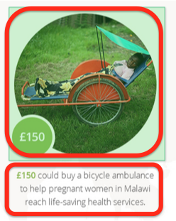

A user thought that the picture determines how much one donates. Users were able to relate to the images, says informative but the text below the images were ignored. The users tried to come up with their own meanings for the images. The **third image** was difficult to relate to.

For users who found amount was above their budget did not really pay attention to the pictures.

One user was not sure if the images simply suggested what the donated amount could do, or if the images suggested what he donated would directly benefit the said beneficiaries.

**GIFT AID: (MAIN ISSUE: VISIBILITY, FAMILIARITY)**

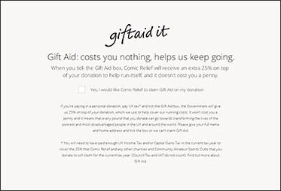

The users (Hollyoakers and corronation streeters) did not read the Gift Aid text and though it was like a **Terms and conditions**, tick the Gift Aid to continue. It has been observed that users without intention to donate skipped the copy without reading it. Few users ignored the copy, two Hollyoakers were not sure about Gift Aid and felt that the explanation was confusing for people unaware about it. They were also confused on the text on who is donating the 25% and assumed it was trying to sell them something irrelevant.

Most of the My Family users thought that the Gift Aid copy was too small and illegible: *“Not that obvious, I could scroll past it”* and would be better as a separate page. Another said, *“There is a fair amount of writing and I would tend to skip it”*. The copy was too long to read even for users who understood what Gift Aid is prior to the study.

**KEEP ME POSTED:**

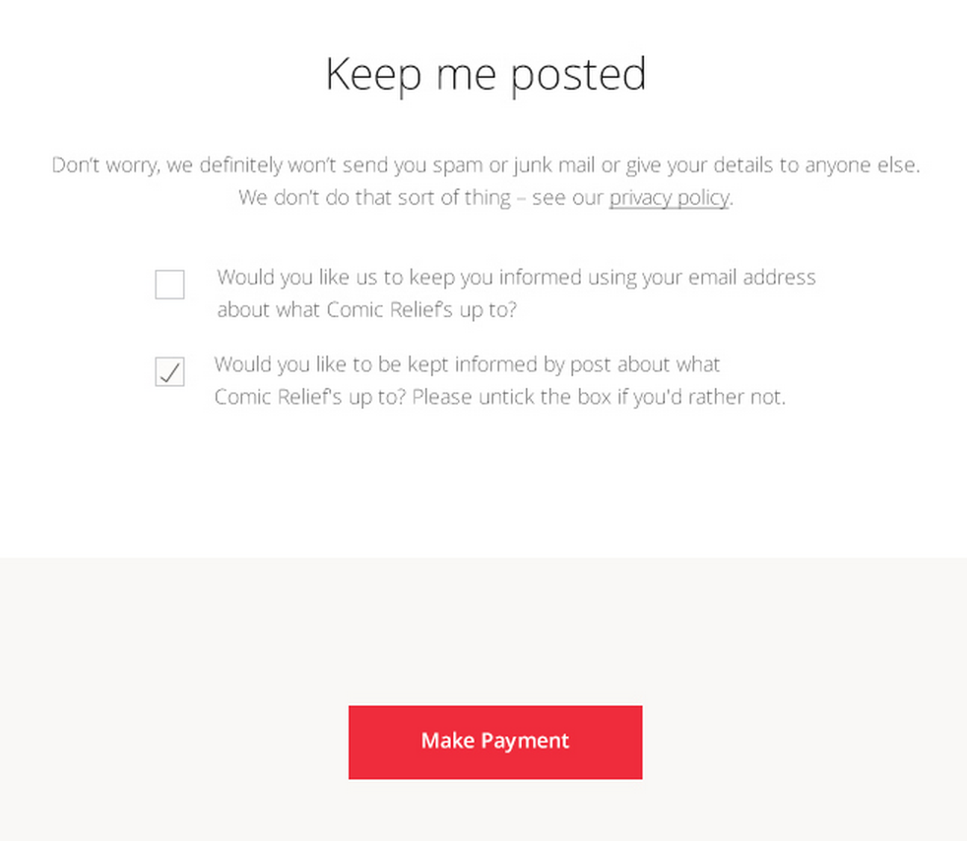

My Family users wondered why the default was on post and not on email, as it costs more to send by post. Two users in “Hollyoakers” and two “Coronation streeters” mentioned that they would make sure they were opt out of any future emails/post, regardless what the defaults were. One user (Coronation Streeter) explained that donation for a charity was usually a one-off transaction for her and she did not want to receive any emails asking for more, *“I want to donate when I feel like so, not when you put pressure on me.”*

**5. Summary of Findings**

The demographics of the usability evaluation were spread over an equal number of “Hollyoakers”, “Coronation Streeters” and “My Family”. There were a number of devices used from small screen mobile phones, tablets to Laptops. People tend to find the process relatively easier in Laptops compared to phones. There were many issues in the donation page which can be further improved (see recommendations section below).

**6. Recommendations**

A number of design recommendations emerged for the Red Nose Day pages during the user evaluation process. The key recommendations are detailed below:

**6.1 General**

1. Ensure good responsiveness of both pages across devices.

**6.2 Landing page**

1. The login to the Giving Page on the top right menu needs to be more obvious. Instead of the icon being an outline of a person, making it solid would add more emphasis and the login text bold.
2. When mouse hovers over the “Get a fundraising kit” button, a photo can be shown (as a pop-up perhaps) to showcase what is in the kit. This would be useful for users who are not regular fundraisers/teachers.

**6.3 Donation page**

1. A copy which says “Choose other amount” and a confirm button can be placed next to this:  
   
2. Continuous scroll design can be kept for desktop/laptop, or when page is displayed in a portrait mode on a mobile device to show the users that the page is continuous and scrollable, with different sections. For devices with smaller screens, a click-through design can be used to lead users through the different stages of donation.
3. A short copy about what Comic Relief/Red Nose day does can be placed above the Moneybuys so users who do not know about the charity or the campaign can understand the context.
4. Improve the copy under Moneybuys so users can better understand the context of the donation recipients.
5. Add a copy to reassure the users that money received from MoneyBuy would directly contribute to the said beneficiaries. (If that is the case).
6. Include a Moneybuy with a smaller donation amount (ie less than £30)
7. Bigger font size and use a darker shade of font colour for Gift aid text.
8. In the second line of Gift Aid it needs to mention about being a UK tax payer to tick the box, rather than having this as part of a large amount of copy which is too small to read lower down.
9. In the Keep Me Posted section, consider breaking down newsletter items further into categories, for example, “Updates on your Moneybuys- how it benefits the beneficiaries”, “Latest at Comic Relief”, “Red Nose Day related”, etc.
10. Email sign ups could be collected by delivering them the transaction confirmation, then prompt the users to sign up for the mailing list.
11. Place social media plugins to allow users to share what they have contributed to Comic Relief, for peer to peer marketing purpose.

**Appendix**

**Demographics Table**

|  |  |  |  |
| --- | --- | --- | --- |
| **Age** | **Gender** | **Device** | **Participant category** |
| 22 | Female | Laptop | Hollyoakers |
| 24 | Male | Laptop | Hollyoakers |
| 25 | Male | LG Nexus 5 | Hollyoakers |
| 32 | Male | iPhone 6 | Hollyoakers |
| 29 | Male | Nexus 7 | Coronation Streeters |
| 34 | Female | Laptop | Coronation Streeters |
| 30 | Female | iPhone 5C | Coronation Streeter |
| 28 | Female | Samsung Galaxy S3 | Coronation Streeters |
| 44 | Female | Samsung | My Family |
| 46 | Female | iPad | My Family |
| 39 | Female | Samsung | My Family |
| 47 | Female | iPhone 5S | My Family |